Note: These instructions are for people with a Google email account and a Windows computer. If you have a different email provider OR use Apple products, your screens may look different.
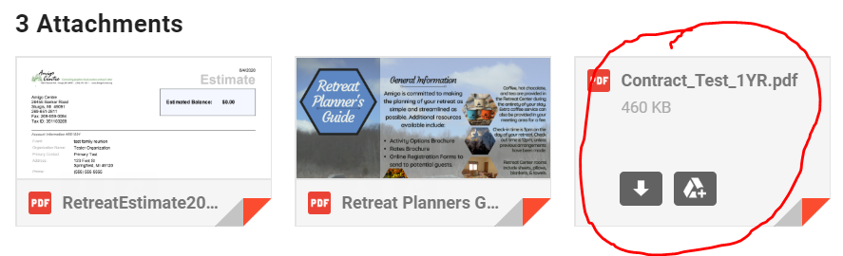
- Click on the link to the attachment on the email.
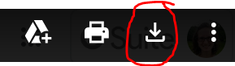
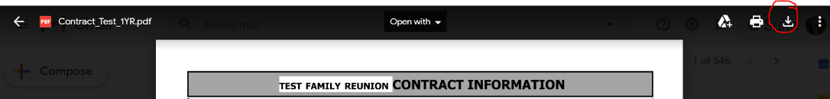
- In the top right of the screen, find the “Download” icon. Click on it.
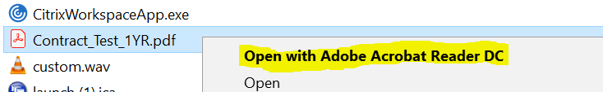
- Find the Contract in the “Downloads” folder on your computer. Right-click the document and choose “Open with Adobe Acrobat Reader.”
- On the far right of the toolbar, click on the button that looks like a pen.
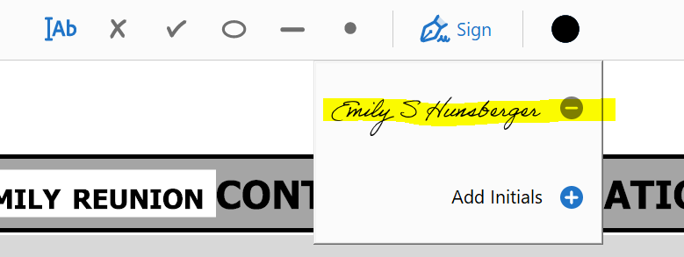
- Click on your signature (note: you may need to create your signature first. Click on this link for instructions on setting up your signature: https://helpx.adobe.com/sign/using/create-electronic-signature.html)
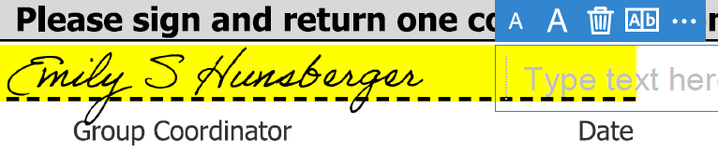
- Scroll to the bottom of the document, then click on the highlighted area to paste your signature there. Then you can click on the line to type in the date
- Click the “Save” icon in the top left of the document.
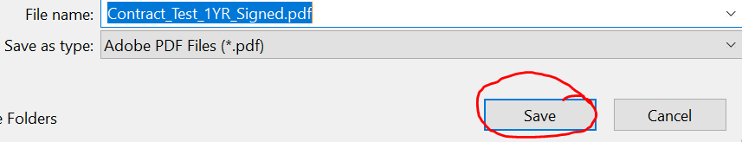
- Choose where you want to save the document. Then add “Signed” to the end of the document name and click “Save.”
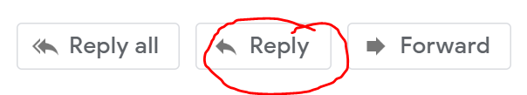
- Return to the email where you received the contract. At the bottom of the email, click “Reply.”
- Click the Paperclip button at the bottom of the email.
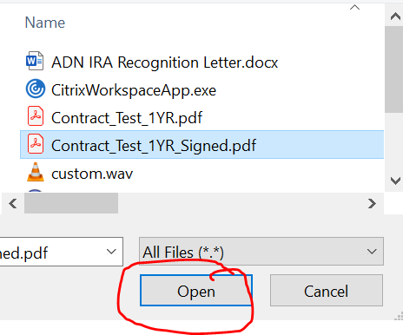
- Choose your signed contract, then click “Open.”
- Type any message in the body of the email, then click “Send.”

